ITC 6400 Final Paper

Siyang Feng

# Catalogue

**Introduction** **2**

Problem Statement 2

The brief description of Technologies 3

Mobile Commerce 3

Cloud Computing 3

Big Data and knowledge management 4

**Business Requirements** **4**

**Competitors Use of Technology** **7**

Uber 7

Airbnb 8

Technology benefiting 9

**Technology Solutions** **9**

Mobile Commerce 9

Cloud Computing 11

Big Data and knowledge management 13

**Recommendations** **14**

**Basic Security Considerations** **15**

**Reference** **16**

**Review and Reflection** **17**

# 

# Introduction

## Problem Statement

Food wasting is becoming one of the biggest issues in Australia. Food wasting comes from mainly two sections. The first one is consumer food wasting. Research [1] from 2016 indicates that every year, people live in Australian waste around 3.1 million tonnes of food. Another one is wasting from industry and retailer who throw away about 2.2 million tonnes per year. Those food waste leave the huge pressure to the waste disposal company.   
A report of Australia poverty in 2018 [2] indicates that there are more than 3 million (around 13.2%) Citizen and Permanent Resident (PR) living under the poverty line which is 50% of median income. It should be mentioned that there are about 739,000 (around 17.3% of the total people who live under the poverty line) under 15 years old children included. Australia has well known as a high welfare benefits country which affords almost all the children cost for their Citizen and Permanent Resident. But the high poverty rate certainly increases the government financial pressure. It should be mentioned that this report also points out there are more 63% people live with government Youth Allowance in the total amount of people (35%) who receive social security payment. Another data shows that Australia’s poverty rate (12.8%) is higher than the average level (12.1%) in the Organisation for Economic Co-operation and Development (OECD).   
Moreover, Australia is also one of the popular countries for international students. A dataset from the Australia government [3] shows that the amount of enrolled oversea student increases every year. The newest data indicates the international student number increased into 869,185 in total grand which is higher than the number of poverty children under 15. A statistic data published in 2017 [4] sorted the international students by its nationality and it’s easy to find out the top five countries in sorted are China, India, Brazil, Nepal, and Malaysia. All of those countries are developing countries. The fee of living oversea occupies the large part of the budget for most of their family.   
Even Australia has a high rate of poverty, its daily costing is still very high. A visualization data [5] summarize the food price about 146 different countries with its price index points collected from the World Bank. The index point of world level is 41. However, Australia is 57 which is higher than the index points, 46, of USA. Comparing those countries with most overseas students coming from, China is only 31 and India is even lower than China which is only 22.

Solution   
Food waste has been one of the majority reason for environmental damage. And considering the finance and society situation, an online platform for unsalable food sell can be a good way to reduce this problem. This online platform can collect the food which is still good but unsalable and sell them in great discount.

## The brief description of Technologies

### Mobile Commerce

Mobile commerce comes from e-commerce which targets on the wireless digital devices such as the smartphone, personal digital assistant (PDA), Iwatch [6]. Mobile Commerce will break the limitation of traditional commerce which means the deal can happen anywhere. In this project, mobile commerce is exactly the most suitable way. The smartphone application is the best choice because of smartphone popularization. Australia is a developed country and it’s nonsense to consider the poverty people has no phone. Also, with social development, there is Wifi covering almost all the majority places. With the APP, it’s easy to allocate the user and navigate to the destination using Google Map service. Moreover, the App is easier to have a function which takes the phone and upload compared to the website.

### Cloud Computing

Cloud computing is the alternative choice for the business physical server provided which is widely used right now especially for the small company who don’t have enough money for the physical server and its maintenance. Its features, ease of setup, no breakdown in logic, no IT backup and maintenance cost and accessible anywhere [7], appeal a lot of small companies to run their business in the cloud server. This project starts with a limited fund. And hiring variance IT workers, engineering developer, server maintenance worker, and the person build a physical server, will waste a lot of time and money. Furthermore, the physical server is also costly and limited in its scalability. Considering a large amount of data storage, a separate data server is needed which will make the server system more complex and costly. In this situation, the cloud server would be more suitable. Cloud computing Structures are divided into Infrastructure as a service (Iaas), Platform as a Service (PaaS) and Software as a Service (SaaA). This program will choose IaaS because it’s already under Deployment from the network to Middleware which reduces the complexity [8] but leaves the flexible space to the Application layer.

### Big Data and knowledge management

The value of big data is not the data itself. People cannot gather useful information anymore from the amount of data by their eyes. Big data has to be processed to get the useful knowledge people needed. In this program, this technology will be used into two major aspects. The first one is using big data to improve our own program and define further business strategy. And the second one is giving business suggestion to our client. In this way, the data, such as page view every half hour, the user registration data, the region with more customer, the popular shops in a period and so on, are recorded and saved. For the first aspect, data of page view, successful deal number per day, user registration number are important to analyze. Also, for the client side, it’s easier to figure out useful knowledge by analyzing the data of the shop itself and the competitors analyzing and so on.

# Business Requirements

The target of this program is to integrate the individual retailer together and sale their unsalable food in a more easier way. For the user, gathering the great discount food together will be easier to get the economical food they want. For the retailer, they can still earn money from the unsalable food which should be thrown away before.

The easiest way to gathering all the items in one is an online platform. In the traditional way, all the food are collected by transfer and sale in a specific place which wastes a lot of money on transport, and the sale is limited by the location. Also, food is special items which can spoil in a short time. All of these reasons limited traditional business. With the online platform, there is no need to collect items together by transfer. The online platform provides the opportunity to gather all the items online with lower cost and high efficiency. Online platform can break the limitation of sale which means wherever people are, they still have the opportunity to find out the economic food they want. In this way, business will be easier expanded to the whole country in a short time. To earn money, online payment tunnel is needed for each deal and the platform will charge a percentage of platform management fee in each deal.

With the development, the platform can have a cooperation with the big market such as Woolworth, Coles, and ALDI and with the cooperation, the platform can extend to the whole country and more and more retailer will register as a seller.

|  |  |  |
| --- | --- | --- |
| Key Technological Requirements: | | |
| Problems | Technology | Brief Description |
| Sale items at a low cost | The online platform, APP | APP is the widely used in mobile Commerce which can do commerce activity anywhere. Easy to access and easy to use. |
| Appeal more people | Good UI design and UX | A good UI can appeal to more people to use and a good UX will positive the user experience. In this way, skills like HTML, JS, and nodejs are needed. |
| Data storage | * DBMS, MySQL * noSQL, MongoDB | * DBMS is the relational database which will be used as the daily data storage under the web server * noSQL is used for further big data analysis and stored in the separate server. |
| Platform development | * Frontend development * Backend development | * Frontend development target on the good outlook and positive user experience * Backend development target on the technical level and development environment. Python is well known in all programming aspects and nodejs are in good time response. Other technologies are considered in different situations. |
| Web server | Cloud server | The cloud server is friendly to a middle and small company. Azure is more friendly when using Microsoft language like C#. Considering multi-language using, Google cloud and AWS are more general. |

At the beginning of this project, the target audience will be those poverty people and others who don’t really care about the quality of the food such as ugly food and that food with the date close to the due date of sale but want the lower price.   
The main method of the most food retailer to solve the deadstock food is to throw away food but only little of them will put food in front of the door for free or discount sale. For the customers, only those who are very familiar with them around food stores can find a way to save money. It’s hard for most of the people to find these kinds of opportunity to get a discount even free food. To reduce the food waste of the retailer side and help customers to save money, the online application is considered to be used. This application requires position navigation and position allocation. When users open the application, they can find the discount food shop nearby. And after click the shop, all the items in sale display with their information on the screen. If the user feels comfortable with the item they can order and pay online. The retailer will receive order confirmation and prepare for the customer. For the food retailer side, retailers upload their deadstock foods into the application and define the price online. That information will be synchronized to the customer side. After each deal accomplishes, customers can rate the shop and its food. The application can get their profit from each deal at the beginning of the business.

The shortcoming of this single business method is the limitation of users. In the beginning, only around 20% of the Australia population is our potential audience. Others may prefer food with better quality. To increase the market share, it’s necessary to appeal the rest 80% of people to use this application. To achieve this goal, the application will generate another function which includes the sale of normal food. The difference in this section and the previous one is normal food sale always defined by the time period. However, the deadstock food sale is defined by the item number.   
For the later business development, a professional function is designed for small dealers by analyzing the data of its deadstock food sale situation and the customer feedback to give the VIP analysis result and suggestions. This function will require additional payment from the dealers.  
To achieve this program, business generalize are required which needs a lot of salesmen offline to broadcast the online sale to shops and person. Online platform (App), cloud server and storage are the three major infrastructure in the program. To complete the project, the server structure should be built and tested the App, also the storage should be tested for stability. To modify this application for functions iteration, an agile programming group is required. To start the business project, a large amount of money is not necessary. But there is still money needed on application generation and maintenance, server payment and offline worker payment.

# Competitors Use of Technology

### Uber

Uber is one of the winners under the big data age. Uber is the biggest taxi company in the word but it has no driver for their own which is in a similar situation. All they are doing is to dispatch and organize drivers and riders. With the technology of Uber, drivers make money and riders save money.

The most significant figure for Uber is its mapping. When open the uber APP, the simple UI with its map and position allocation is attractive and easy in use. Uber map combines the datasets, mapping algorithm, position allocation and routing together. Gurafu, one of the highest-volume service, is used for the mapping service. Gurafu includes the technology of prediction engine, auto-complete search engine and the geocoding service [9]. In detail, Uber obtain the user location via CoreLocation framework in iOS platform and google map geolocation feature in Android. It’s the very basic and necessary step for the APP running because the major smartphone is Android and iOS. One of them losing will lose half the market in business. For Uber navigation generated in two sides, rider and driver. To make the routing available, Uber uses MapKit in the iOS system and Google map API in Android system [10]. One of the similar section with Uber is that mapping is a significant feature in the program. But the difference is we don’t need such high time response which will reduce the technology requirement in our project.

For the infrastructure, Uber runs its business on the hybrid cloud model which mix the private cloud service and public service together. For uber, to reduce the risk of data center fail, they mix the multiple activity data centers and cloud providers together and run the trips in parallel [9]. For the data storage aspect, the available disk storage increasing and the system response time decreasing are required with the business growing. Riak and Cassandra which have the feature of low-latency and Schemaless which replace MySQL for its better performance are used in the Uber storage system.

### Airbnb

Airbnb has more similar conditions comparing with Uber. It offers the low price residence on their online platform and our project provides lower price food. The difference is Airbnb can perform great on both website and APP. But our project is better on APP which is similar to Uber.

The most significant feature in Airbnb is its big data analysis and machine learning technology. They use this technology to improve their service, guide the price and bridge the gap between the guests and the company profit and benefit [11]. Airbnb collects the back data such as property price and position, guest rating, the keywords of guest evaluation, and the occupancy rate and so on to generate a model to predict if the residence is reasonable. Airbnb uses the heatmap and boxing plot to classify their residence into a different level for the recommendation.

### Technology benefiting

These two companies are all in successful business which is benefit from the IT technology especially the big data. The technologies of the mapping system in Uber is great and can be used in our project for the low latency allocation and navigation. Also, the big data storage structure can also provide an idea for our data storage. Moreover, the big data recommendation analysis is a good idea our project can learn from.

# Technology Solutions

### Mobile Commerce

Mobile commerce has been one of the most popular methods in the modern market which is friendly to the smartphone. However, one APP is suitable for all mobile systems. Luckily, there are only two major operating systems in the market. So we only need to consider those two. Data [12] from Apr 2017 to Apr 2018 indicates that iOS occupied around 55% in the mobile market and Android was about 42%.

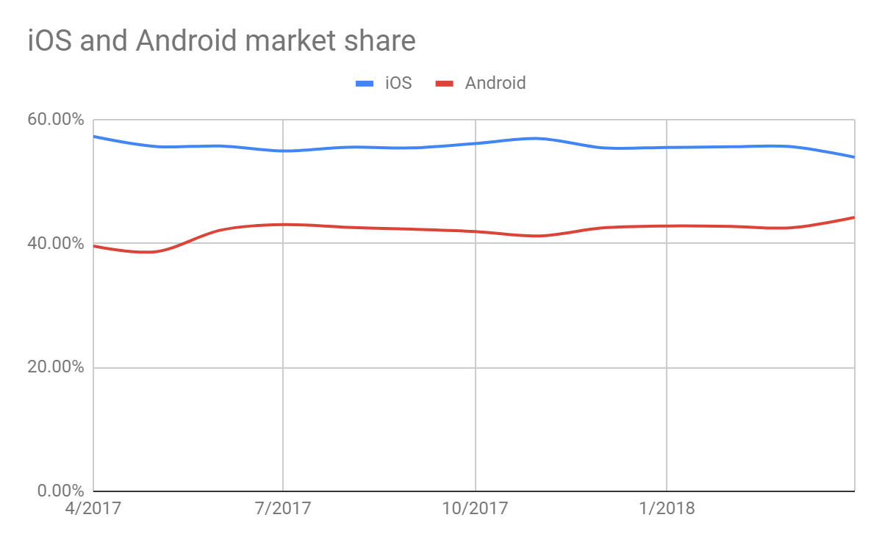  
The figure illustrates that it’s better to generate two APPs for iOS and Android users together. However, as the company just start, it’s hard to generate two at the same time. Thus, considering the market sharing, iOS application can generate first. Also, a new Swift programming language for iOS development is in use for the iOS 8 and higher. This language is easier and well designed than Java for Android to reduce the cost of development. After the first iOS application pushing into the market and the analyzing of functions and user feedback, the Android application can be considered to develop.

UI and UX development for a frontend are considered in this section. For the UI design, screen fitness should be considered first. Then, the contrast of the color used, the text size, touch control and so on are all needed to be considered for the usage. UX is the concept to improve the user experience. In this project, the map should be clear enough to allocate where the user is and the position of the shop in a discount as the graph shows. This graph displays the UI sketch with the main features inside. The top search button is the filter to select the preferred food.

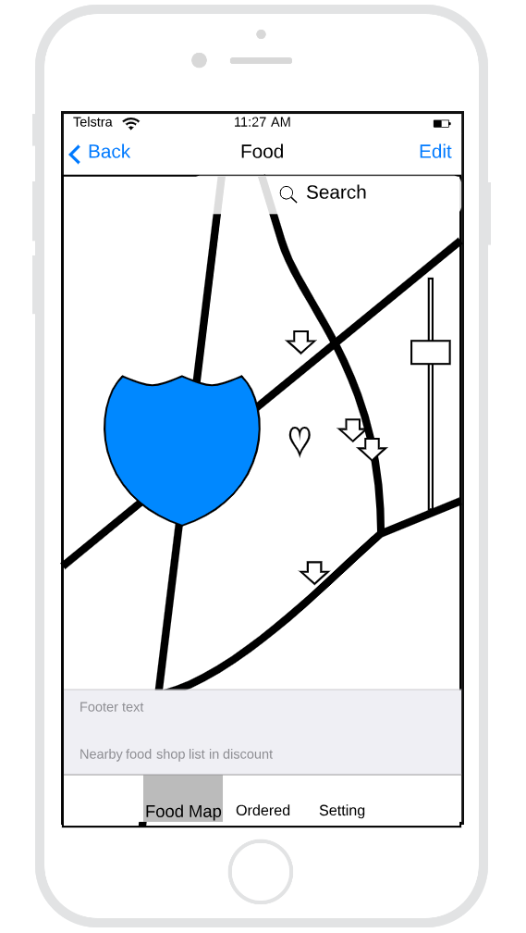

As the sketch shows, the major function of this application is to allocate the location of the user and search the stores with discount nearby. App feature has the easier method to allocate the geographic location via the platform of CoreLocation in iOS. In this function, google map is required for navigating. But the problem is that google map needs purchase from 2018. Thus, more money may need for this function or find an alternative map. Considering the Uber map navigating, Uber uses MapKit for iOS. It can be an alternative selection. However, the Android system still relies on the Google map API. It will cost a lot if create a map by ourselves. Because generating a map with detail for whole AU is a huge task and time-consuming. Also, hand generation map is not synchronous and maintenance will also take a long time and a lot of money. Also, whatever the map from, the Map API adaption is the big issue in this function. As the backend of the application, Swift is the majority language to build the App. But for the server environment, Python and JavaScript can be considered as the first choice.   
For the user side, the functions run as following.  
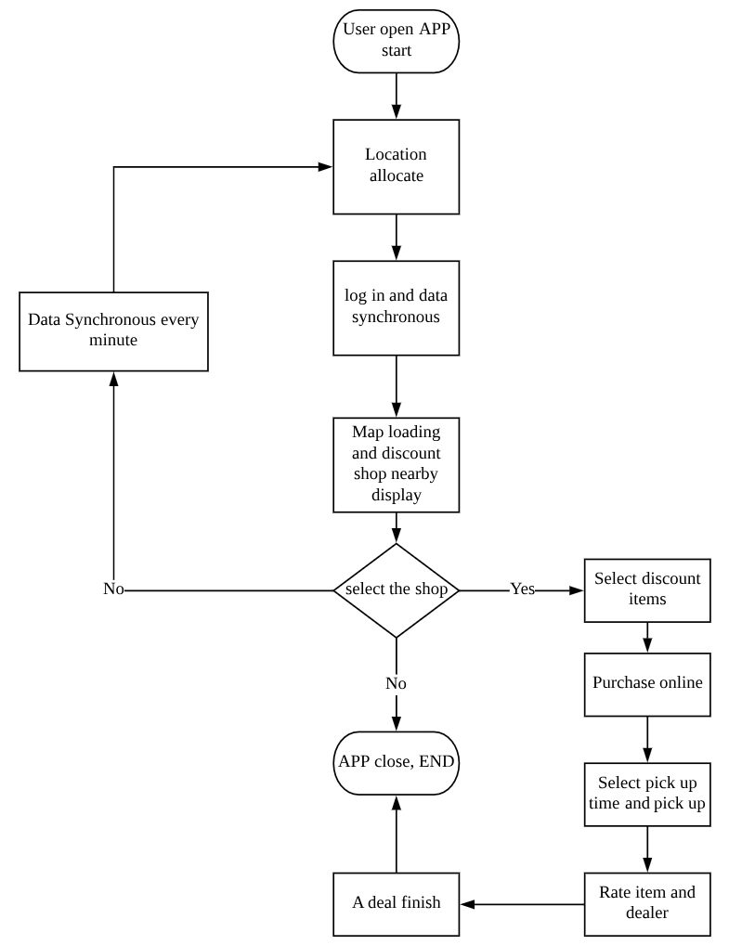

For the retailer side, there are at least two main functions:

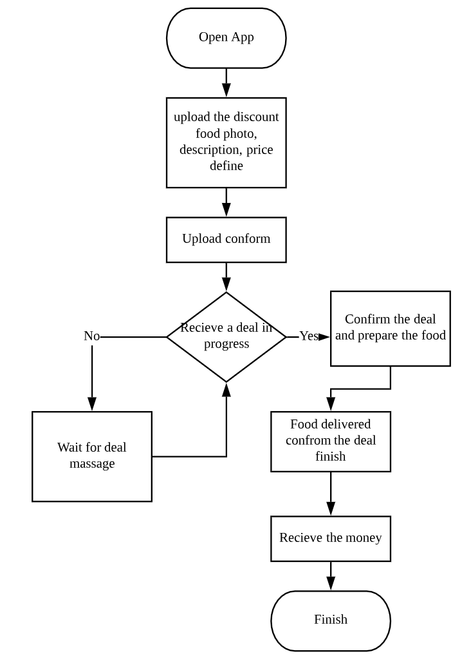  
The job can be finished in App but still, need data synchronization with the online server.

### Cloud Computing

Cloud computing is needed to the cloud server. For this business project, the cloud server is more suitable than the physical server. The company just start without wide resources and only limited money. It’s hard for the new company to analyze what kind of physical server is best and it’s extremely hard to predict the scalability of the physical server. A server with a lot of unused computing ability will waste a lot. On the contrary, less scalability server is not suitable for further company development.  
For the could server, there is no need to spend money on server maintenance and consider the scalability of the physical server. It’s just the virtual machine server. In some situations, if there are more servers needed, just purchase more money for more server support. It’s more flexible than the physical one. IaaS cloud structure is more suitable in this program. In this structure, the layer of network, Virtualization, OS, Database, and Middleware are predefined by the cloud. Above the middleware, an application still needs to develop. This application is the web server application which manages the whole functions and the data through. The web server needs a quick response with the user-end App. At least two servers are needed in this case to generate the Hybrid cloud structure for the flexibility, scalability and security features. One is used for software server which is the public cloud. And another one is for data only which is a private cloud. In this project, we have a service for data analysis and a lot of data will be collected for the business. A separate data server will keep the data safer than put it into a software server. The problem should consider is bandwidth for data transfer. Because every time, software server want to process the data and it has to require the data from data server which spend more time and occupy a lot of bandwidth. One method to solve this problem is to separate the data analysis program into the data server and use the computing ability of the data server to solve data analysis problem and only transfer the result to the application server.  
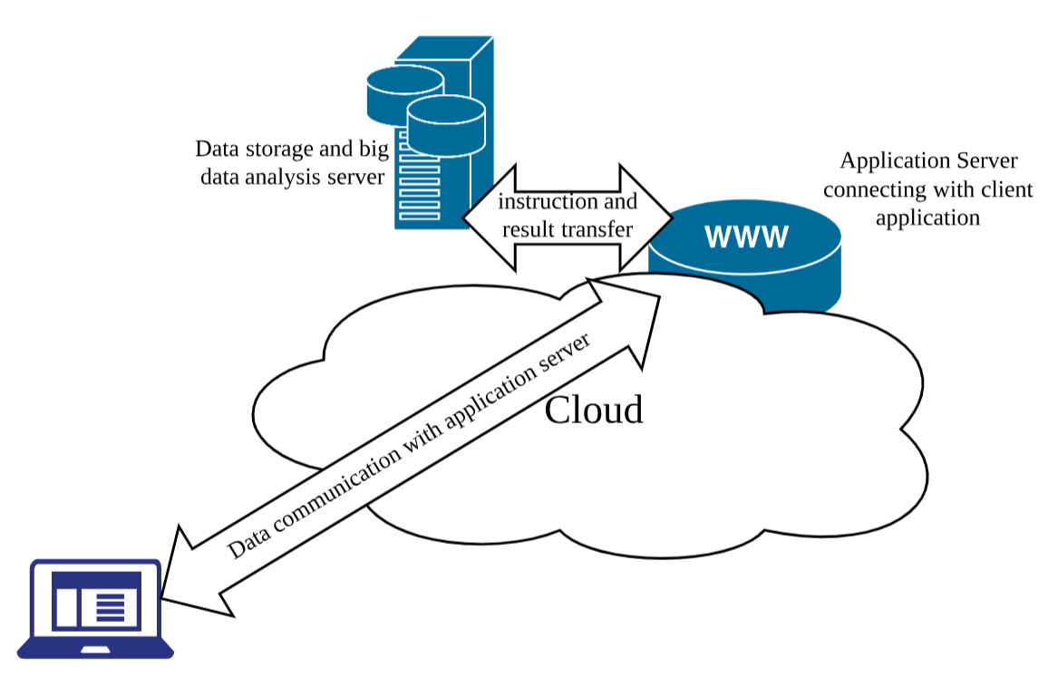

### Big Data and knowledge management

Big data is always needed in nowadays business and good big data analysis often lead a business successful. Python and R is the most popular tool for data analysis.

* Data in the collection:
  + Personal information of user and retailer such as the position: collected by user typing and can store in related DB;
  + Number of the register in a certain period: web server sensor generate this kind of data by counting in a certain time;
  + Dealing information and status: web server will record this data by testing the status and recording;
  + Food information such as condition and price: retailer input this kind of data;
  + User rating and evaluation: these kinds of data come from the user input after each deal;
  + Page view in a period: steam data, record by web server sensor;
  + Server log and accident: steam data, server sensor record this data;

There are a lot of data are collected with variant types which require NoSQL storage especially for the log and accident. It’s hard to create a relational database with the normalization. noSQL stores the data by key-value pair, wide-column oriented, document-oriented or Graph oriented storage structure [13].

* Big data processing structure:

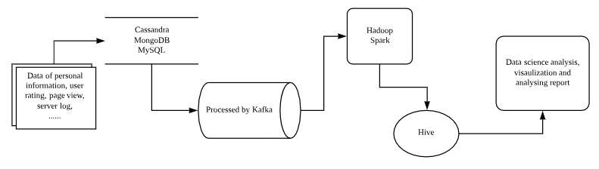

Before getting the useful information, the original data should be processed with the big data service application such as Kafka, Spark and Hive. And then, data science can analysis the processed data and visualized them to get the knowledge needed. The knowledge management is the final section in the whole processing.

For example, collecting page view every hour or every half day to analyze when the business is most popular and find other evidence to figure out the reason why the time is popular and the reason other time is not such popular. In this way, it’s easy to find out the idea to improve the business and get more profit. Moreover, long-time data analysis for page view and its influence factor data can predict the business scale in the future and prepare for the future business strategy such as server scalability and investment prediction.   
The VIP service for the retailer is to analyze its sale condition and give some suggestions. In this way, the sale condition about this store and the user rate for this store are collected during this period. Also, the previous period data about this store. Other similar stores data can also be collected to have a comparison. In this way, weakness and strength are more clear than ever before.   
For the big data analysis, Python is preferred. As this language can be used as a backend language and also data analysis and very popular nowadays. It’s good to use the same language for backend and data analysis. Intelligence big data analysis sometimes requires auto-analysis in the backend and translate the result. If any other language is used, there still need a connector between those two. More connector used the more complex the system is. And with the complexity of system increasing, there always be more bugs.

# Recommendations

Combining the part of the application platform, big data analysis, and cloud computing talking above is the all about Mobile Commerce. In conclusion, the APP in mobile can be widely used and easy for location allocated which is one of the biggest function in this project. Another significant function of the VIP function which helps the retailer to get a better business strategy in the next period. This function requires a lot of big data analysis processing for a particular shop. Besides the function, company development also needs big data analysis support. For the backend, a could server with cloud computing is the best choice which can reduce server cost and get more scalability.   
There is a lot of benefits. In general, combining the APP in mobile, big data, and its analysis, and cloud computing with its server can have the most convenience usage and largest market in Australia, the most convenient way to analyze the future development of the company and provide the similar service to other retailers to earn more money. Could server can reduce the server cost and in this way, the company can pay most of their attention on their e-business to get better development.

In the future, the two major functions can be developed that expend the unsaleable food discount to all the discount items information nearby gathering. Also, expend the retailers' suggestion function into the consulting group for all retailers who need help. In this way, the target audience will be extended from the poverty people and food shop who contains unsaleable food into all the people who want discount items and all the shops who want to extend their business or at least earn more money.

# Basic Security Considerations

Security and personal data privacy are one of the hottest issues in the world.   
1. The cloud server is a very safe server because there are a lot of professional workers working together to enhance server security. But it’s also the most unsafe server because there are thousands of hackers target to steal the data in cloud company. There are a tremendous number of data in one cloud server company which worth a lot. For this program, all the data and normal data processing and analysis processing are in the data storage server which reduces the data connection between the data storage server and application server. The best way to prevent data stolen is to monitor the data income and outcome. Every large number of data transfer will be recorded in the monitor and track the destination IP to figure out if the process is in normal condition.   
2. The select the third part company for the technical support, the most important thing is to consider if the third part company is in good reliable and stable. Search the information to find out if the company has an accident and how they solve the problem.   
3. The company should supply the monitor system to monitor all the data going in and going out and record the destination of the data. Every one or two months, the inspection is supplied to detect is there any harmful spy in the log of the server to reduce the inspection level. Moreover, security applications and equipment uploading are necessary after the new version is stable.

# Reference

[1] Tackling Australia's food waste. (n.d.). Retrieved from <http://www.environment.gov.au/protection/waste-resource-recovery/food-waste>   
[2] U., & A. (2018). Poverty in Australia 2018. Retrieved January 22, 2019, from <https://www.acoss.org.au/wp-content/uploads/2018/10/ACOSS_Poverty-in-Australia-Report_Web-Final.pdf>   
[3] International Student Data 2018. (2018). Retrieved January 22, 2019, from <https://internationaleducation.gov.au/research/International-Student-Data/Pages/InternationalStudentData2018.aspx>.   
[4] <https://www.studiesinaustralia.com/studying-in-australia/why-study-in-australia/international-students-in-australia>   
[5] Australia – Food prices. (n.d.). Retrieved from <http://www.mytravelcost.com/Australia/prices/food_prices/>

[6] What is m-commerce (mobile commerce)? - Definition from WhatIs.com. (n.d.). Retrieved from <https://searchmobilecomputing.techtarget.com/definition/m-commerce>   
[7] Compare Project Online and Project Server 2013. (2016). Technet.microsoft.com. Retrieved 10 April 2017, from <https://technet.microsoft.com/en-us/library/dn268595.aspx#Anchor_1>

[8] Cloud computing: A complete guide. (n.d.). Retrieved from <https://www.ibm.com/cloud/learn/cloud-computing>

[9] Uber Engineering's Tech Stack: The Foundation. (2018, December 21). Retrieved from <https://eng.uber.com/tech-stack-part-one/>

[10] 1691821457546794. (2017, December 31). How Uber was made – freeCodeCamp.org. Retrieved from <https://medium.freecodecamp.org/how-uber-was-made-da3c631066d0>

[11] Rizvi, S. A. (2018, October 06). Airbnb offers World Class service – Thanks to Big data and Machine Learning. Retrieved from <https://www.simplilearn.com/airbnb-uses-big-data-machine-learning-article>

[12] Market share of mobile operating systems in Australia from April 2017 to April 2018, Retrieved from <https://www.statista.com/statistics/861532/australia-mobile-os-share/>

[13] Types of NoSQL Databases. (n.d.). Retrieved from <https://www.mongodb.com/scale/types-of-nosql-databases>

# Review and Reflection

In this report, I have learned how to write a technical proposal which needs more detail in technology. At the beginning of this class, a technical proposal in my mind is just the high-level guide for one project which doesn’t need any specific technology mentioned. And the detail will be discussed in developing the group later. However, the truth is I have to organize the whole structure of the project including its business strategy and technologies in using related its business requirements. To do this proposal, it’s important to have the whole concept of the program and good experience on the whole structure design. I have no idea about the position in a career to do this job. But it’s still a good opportunity to practice.

In detail, I have a deeper understanding of the business requirement. Also, the deeper understanding of the concept of mobile commerce, cloud computing and the relation between the big data and knowledge management. This paper gives me more concept which I never heard before in business but I find those are also important in technical achievement. It’s true that technology cannot achieve without the society needed. So, it’s important to combine them together and it’s also the key to success a project.

That’s the reason Uber and Airbnb to succeed. With the deeper understanding the Uber technology, there is a lot of ideas which is helpful for my project. There is a lot of similar concepts which hint me a lot. I think that is the reason why competitor analysis is very important.